JENKINS INTEGRATION

1. Installing the Jenkins and get the password

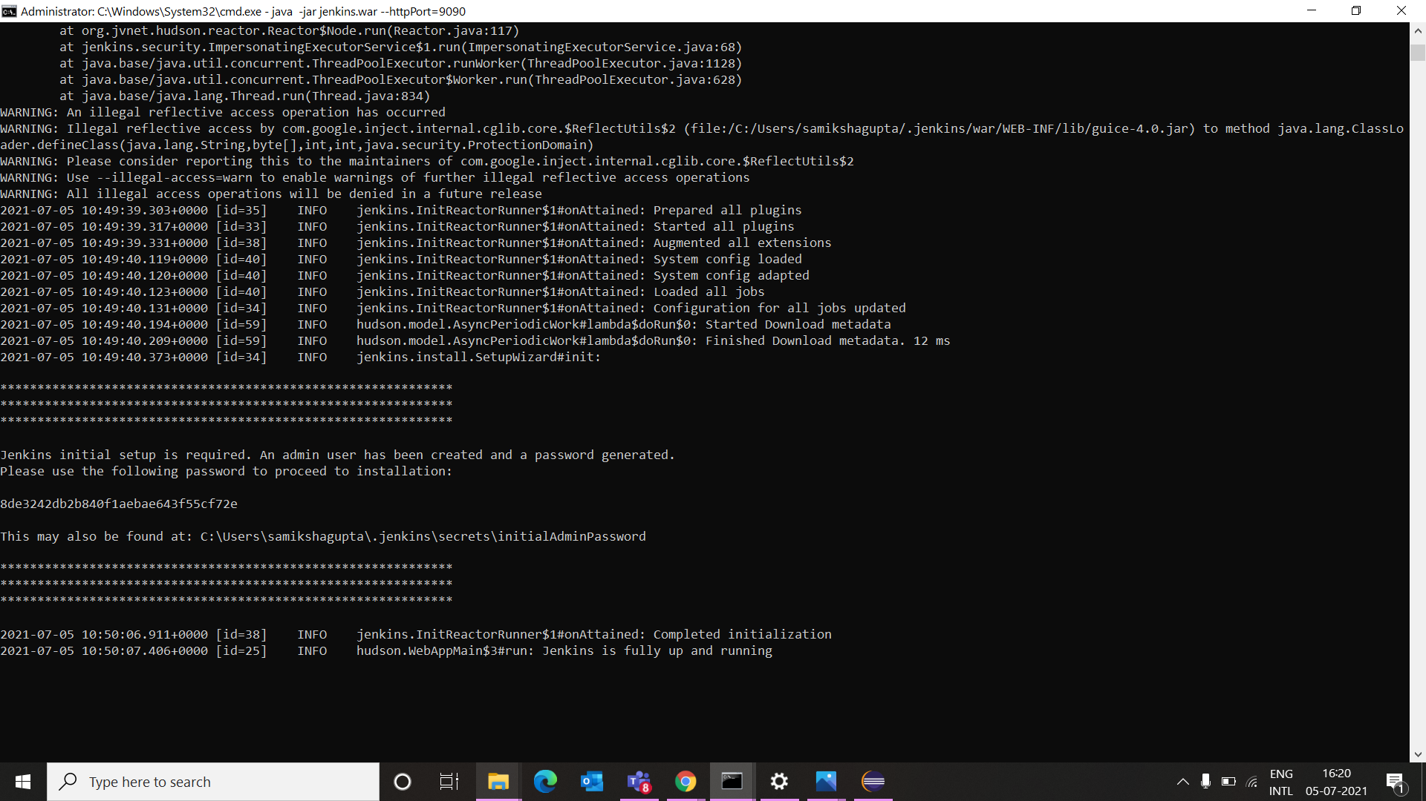

1. Open the localhost:9090 port

1. Add some plugins from manage plugins option

1. Create New project

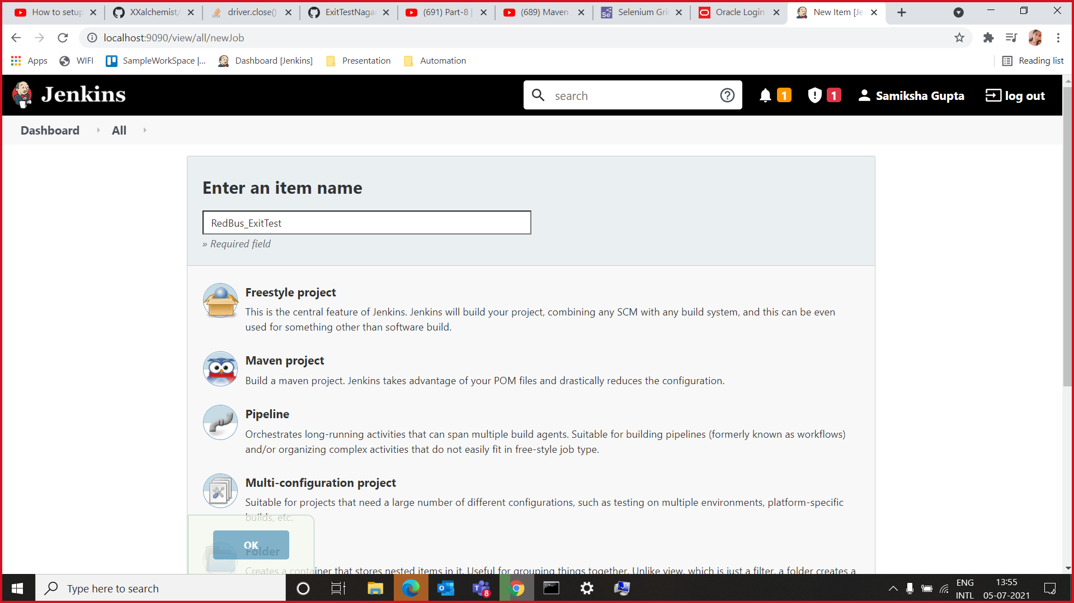

1. Link the Project With Github repo

1. Project created successfully & click on build now

1. Console Output

FINAL OUTPUT

